West DC: Risk
Assessment

Course Identification: UH35

Course: UH35 Hill Climb, Claverton Hill, Claverton, Bath | Road(s) Assessed: Claverton Hill, unclassified road
10 pages including 8 including photographs | Date of Assessment: 9th September 2019

Cycling Time Trials – West DC Course Risk Assessment Document:

The measures to reduce risk identified in the right hand column must be included on the start sheet or implemented for the duration of the event as applicable. Failure to comply with the requirements of this document may result in approval being withheld with respect to subsequent race promotions by the promoting club.

Organisers Comment:

The full course (UH35) runs from Claverton village, up Claverton Hill, past The American Museum and finishes on the brow of Claverton Hill where the road flattens out into The Avenue.

This dynamic risk assessment reduces the length of the course to be used, locating the finish at the stone pillars positioned on each side of Claverton Hill downhill from the main entrance to The American Museum.

The primary reason for this is:

- The main public access into The American Museum is no longer on the course, with improved vehicular access especially for vehicles turning right when leaving the museum which includes the museum shuttle minibus that provides transport for visiting members of the public between the City of Bath and the museum.

Restrictions:

No. | Distance / Location | Risk / Hazard | Level of  Risk  (L/M/H) | Measures to Reduce Risk  (if applicable)
a) Introduction
1 | General Requirements.  Traffic Standards | Time of Road Usage meets CTT Traffic Standards | L | Traffic counts are within acceptable numbers.  Move finish line as organisers comments above so entrance to The American Museum are off the course.  Finish line marshal to take Traffic Counts during the event.
2 | General requirements.  Event car parking. | Riders parking along or at:  Bath University  The Avenue (limited public roadside car parking opposite the Bath Cats & Dogs Home).  Bath Cats & Dogs Home (private car park for use by customers only)  The American Museum (main car  park for use by customers only)  Claverton Hill (inc the course, no designated car parking)  Claverton village (small village at the bottom to Claverton Hill).  A36 Warminster Road (fast main road at the bottom of Claverton Hill, no designated car parking) | L | Event car parking, HQ, sign on, toilet provision and post event prize giving is located at the Bath University Sports Training Village, HQ on the balcony overlooking the running track. 2 or 3 x gazebos to be used.  Instructions on start sheet to include:  Use East Car Park which is closest to the event HQ and allows on foot access.  Request riders not to park in the public parking spaces along The Avenue, keeping these clear for members of the public.  Do not use the Bath Cats & Dogs Home car park for attending the event. Private car park, for use by customers only.  Do not park along Claverton Hill.  Do not park in Claverton village. No parking for riders at the start line.  Do not park in or restrict access to the American Museum.  Do not park on the A36 Warminster Road.  Further actions to include:  Marshal & cycle event signage (visible to both directions) at the access to the event car park and HQ.  Instruct the all drivers and riders at HQ to take care when leaving the event car park.
3. | General requirements.  Event toilet provision. | Provision of adequate toilets. | L | Use of the café and related toilets which are close to both the sign-on desk and parking.  No toilet or food facilities available on the course.  No bikes inside the Training Village.  Cleats should not be worn inside due to risk of slipping.
4. | General requirements.  Event catering. | Provision of food and drink. | L | See above comment

5. | General requirements.  Competitors warm up and route to the start. | Use of the A36 Warminster Road which is a fast main road at the bottom of Claverton Hill. |  | H | A36 Warminster Road must not be used by riders for warm up or route between HQ & start. Instruction on start sheet. Advise the riders at HQ.  Cycle event signage at the junction of the A36 and Claverton Hill to warn approaching vehicles.
6 | General requirements.  Competitors route to the start from the event HQ. | Competitors riding to the start down the course during the event, with competitors riding up. |  | L | Marshal course. Advise the riders to proceed slowly and with caution, keeping to the left hand side of the road. Instruction on start sheet. Advise the riders at HQ.
7. | General requirements  Start area. | Competitors gathering to wait in holding area in Claverton village at the start. |  | L | Marshal the holding area, which is located just before the start line in the left hand turning (when approaching down Claverton Hill). Advise riders to line up, single file in number order, keeping to the side of the lane and await the marshals’ instruction to proceed to the start line. Instruction on start sheet. Advise the riders at HQ.
8. | General requirements.  Competitors and  spectators gathering at The American Museum entrance. | Competitors and spectators causing obstruction at the main public entrance to The American Museum. |  | L | The club continue to liaise with the Deputy Director of The American Museum to co-ordinate the hill climb event.  The following was agreed:  - Finish line to be located by the stone pillars downhill from the museum entrance to the effect that the museum entrance and car park is not accessed from the course.  - Time keepers & marshals are permitted to use the grass verge in the museums ownership.  - Finish line marshal to act as the competitors ‘catcher’ to assist finishing riders regain their breath and move safely away from the finish line area.  - Marshal at the museum entrance to direct competitors and spectators downhill, past the stone pillars and away from the museum entrance or uphill back to the event HQ.
b) HQ to Start – Riding Down the Course
9. | General requirements | Competitors riding from the event HQ to the start and Competitors warming up.  The road is not closed, public vehicles, pedestrians etc. present. | L |  | Instructions on Start Sheet and at event HQ (signing on) advising riders of the route, to keep left and descend slowly taking care for vehicles, pedestrians and other competitors.  A36 Warminster Road not to be used. Prohibition on riders warming up on the course while the event is underway.

10. | 125m from the Finish. | Narrowing of road at brow of hill. | L | Event warning signage to be clearly in view to drivers and cyclists.
11. | 100m from Finish | Footpath on the right hand side when descending.  Walkers accessing Limekiln Lane & Claverton Hill. Competitors also coming uphill. | L | Cycle event warning sign. Advise the riders to ride on the left and descend at slow speed.
12 | 20m from Finish | Steep road with public entrance and exit to American Museum on the left when descending. Straight section of road with good visibility.  Riders also coming uphill. | M | Marshal entrance to American Museum. Direct spectators downhill from the museum and finish line. Cycle event warning sign. Instruct the riders to descend at slow speed.
13. | Finish between the stone pillars after The American Museum entrance. | Riders also coming uphill. | L | Finish line marshal to act as the competitors ‘catcher’ to assist finishing riders regain their breath and move safely away from the finish line area. Provide cycle event warning signs either side of the Finish. Advise the riders to descend at slow speed.
14. | 650m from Finish | Entrance to residential property, Vineyards Farm, on the right when descending. | L | Marshal entrance. Cycle event warning sign. Advise the riders to ride on the left and descend at slow speed.
15. | 800m from Finish | Left hand bend (3m road width) followed by right hand bend (4m road width. Reduced visibility, riders also coming uphill. | L | Marshal each bend. Cycle event warning sign. Advise the riders to ride on the left and descend at slow speed.
16. | Area of Start | Competitors waiting to start. | L | Marshal waiting area. Riders wait in side road 5 metres from start, lined up in single file in number order, one rider only at start point to keep start clear. Instruction on start sheet. Advise the riders at HQ.
17. | 85m after Start | Access onto A36 Warminster Road. High speed traffic on the A36. | H | Marshal junction. Cycle event warning signs each side of junction. A36 Warminster Road not to be used for warm up or route between HQ & start. Instruction on start sheet. Advise the riders at HQ.
c) Start to Finish – Riding Up the Course
18. | 85m before Start | Access onto A36 Warminster Road. High speed traffic on the A36. | H | Marshal junction. Cycle event warning signs each side of junction. A36 Warminster Road not to be used for warm up or route between HQ & start. Instruction on start sheet. Advise the riders at HQ.

19. | Area of Start | Competitors waiting. | L | Marshal waiting area. Riders wait in side road 5 metres from start, lined up in single file in number order, one rider only at start point to keep start clear. Instruction on start sheet. Advise the riders at HQ.
20. | 100m from Start | Right hand bend (4m road width) followed by left hand bend (3m road width). Reduced visibility, riders also coming downhill. | L | Marshal each bend. Cycle event warning sign. Advise the riders to ride on the left.
21. | 320m from Start | Entrance to residential property, Vineyards Farm, on the left when ascending. | L | Marshal entrance. Cycle event warning sign.
22. | Finish | Competitors obstructing the carriageway after finish. | L | Instruction to the riders at HQ sign on not to stop at the finish, and to be aware of their surroundings and other road users. Instruction on start sheet.  Advise the riders at HQ.  Finish line marshal to act as the competitors ‘catcher’ to assist finishing riders regain their breath and move safely away from the finish line area.  Provide cycle event warning signs either side of the Finish. Advise the riders to descend at slow speed.
23. | 20m after Start | Entrance to American Museum on the right when ascending. Straight section of road with good visibility. | M | Marshal entrance to American Museum. Direct spectators downhill from the museum and finish line. Cycle event warning sign. Instruct the riders to descend at slow speed.
24. | 100m from Finish | Footpath on the left hand side when ascending. Walkers accessing Limekiln Lane & Claverton Hill. Riders and public vehicles, pedestrians etc. also coming downhill. | L | Cycle event warning sign. Advise the riders to ride on the left.
25. | 125m from Finish  (at the usual UH35 finish line) | Right hand turn into the event HQ. Junction located where Claverton Hill and The Avenue meet.  Riders and public vehicles, pedestrians etc. also coming downhill. | L | Instructions on Start Sheet and at event HQ (signing on) advising riders of route after finishing and to take care for other road users.  Marshal the car park entrance and provide cycle event warning signs to either side of the entrance.

This document remains live and any changes to the items listed above or new hazards/risk that arise should be notified to the district committee at the earliest opportunity. This document was last updated on 9th September 2019.

CYCLING TIME TRIALS IS A COMPANY LIMITED BY GUARANTEE REGISTERED IN ENGLAND No: 4413282
Registered Address: 77 ARLINGTON DRIVE, PENNINGTON, LEIGH, LANCASHIRE, WN7 3QP. November 2003

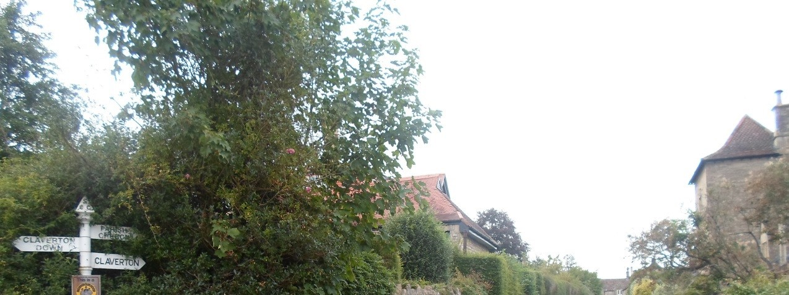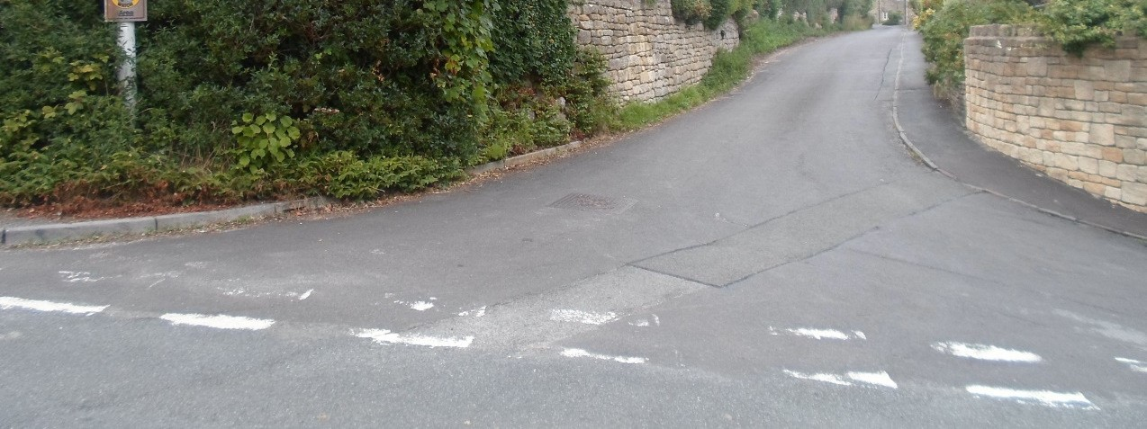

Photo 01: Waiting Area in Claverton Village

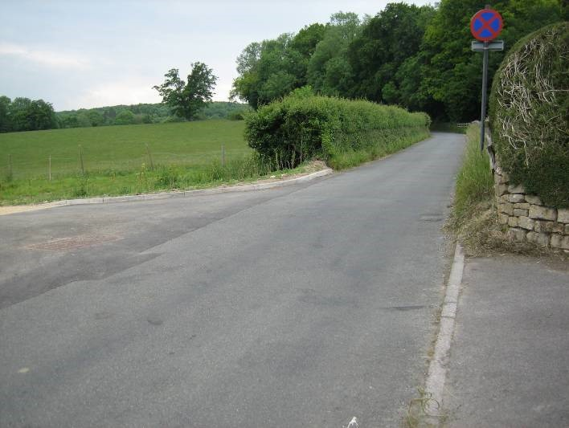

Photo 02: Start Location (where the kerb finishes uphill from the gated entrance)

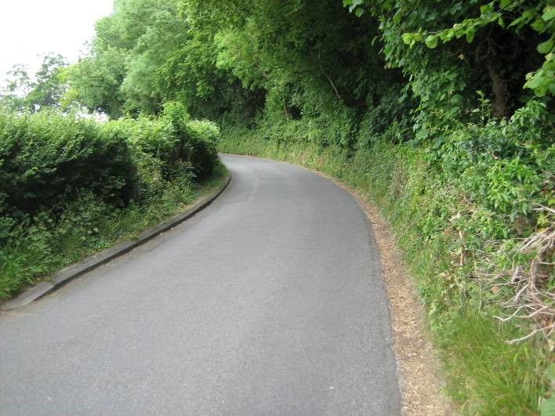

Photo 03: Right hand bend 100m from start

Followed by:
Photo 04: Left hand bend

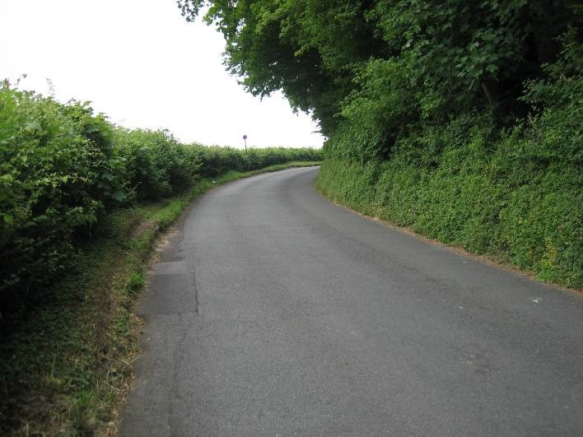

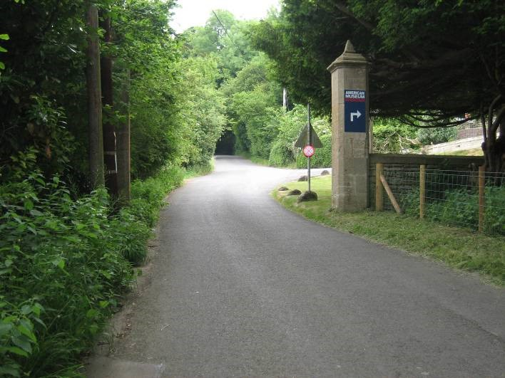

Photo 05: Finish Line Pillars and Access to American Museum

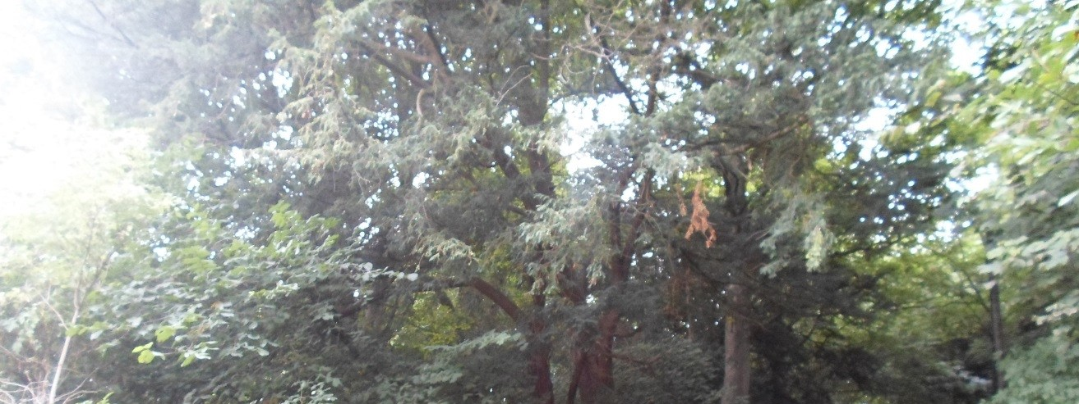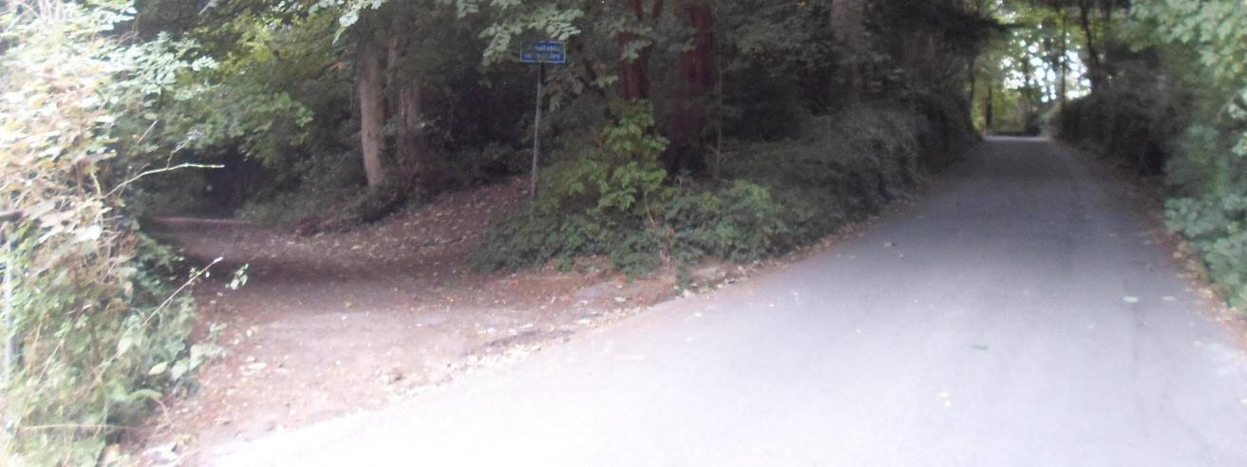
Photo 06: Access to Limekiln Lane after (uphill from) the finish

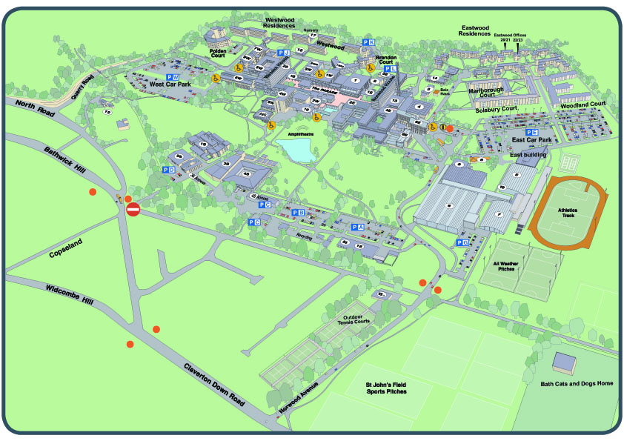

Photo 07: Event car park and HQ area (Bath University Sports Village Balcony + East Car Park).

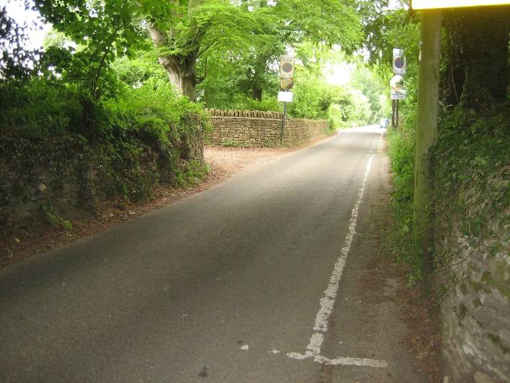
Photo 08: Narrow approach from The Avenue to the top of Claverton Hill and event HQ.

